**ASSIGNMENT DAY 21**

In the Assignment 21 of Week 6, we are asked to apply Object Level Security to our Filled Map visual of Assignment Day-10. Therefore, here are some snapshots of the same i.e application of OLS on the visual with the help of a external tool Tabular Editor.

Here, the below snapshot the shows the application of OLS on City .

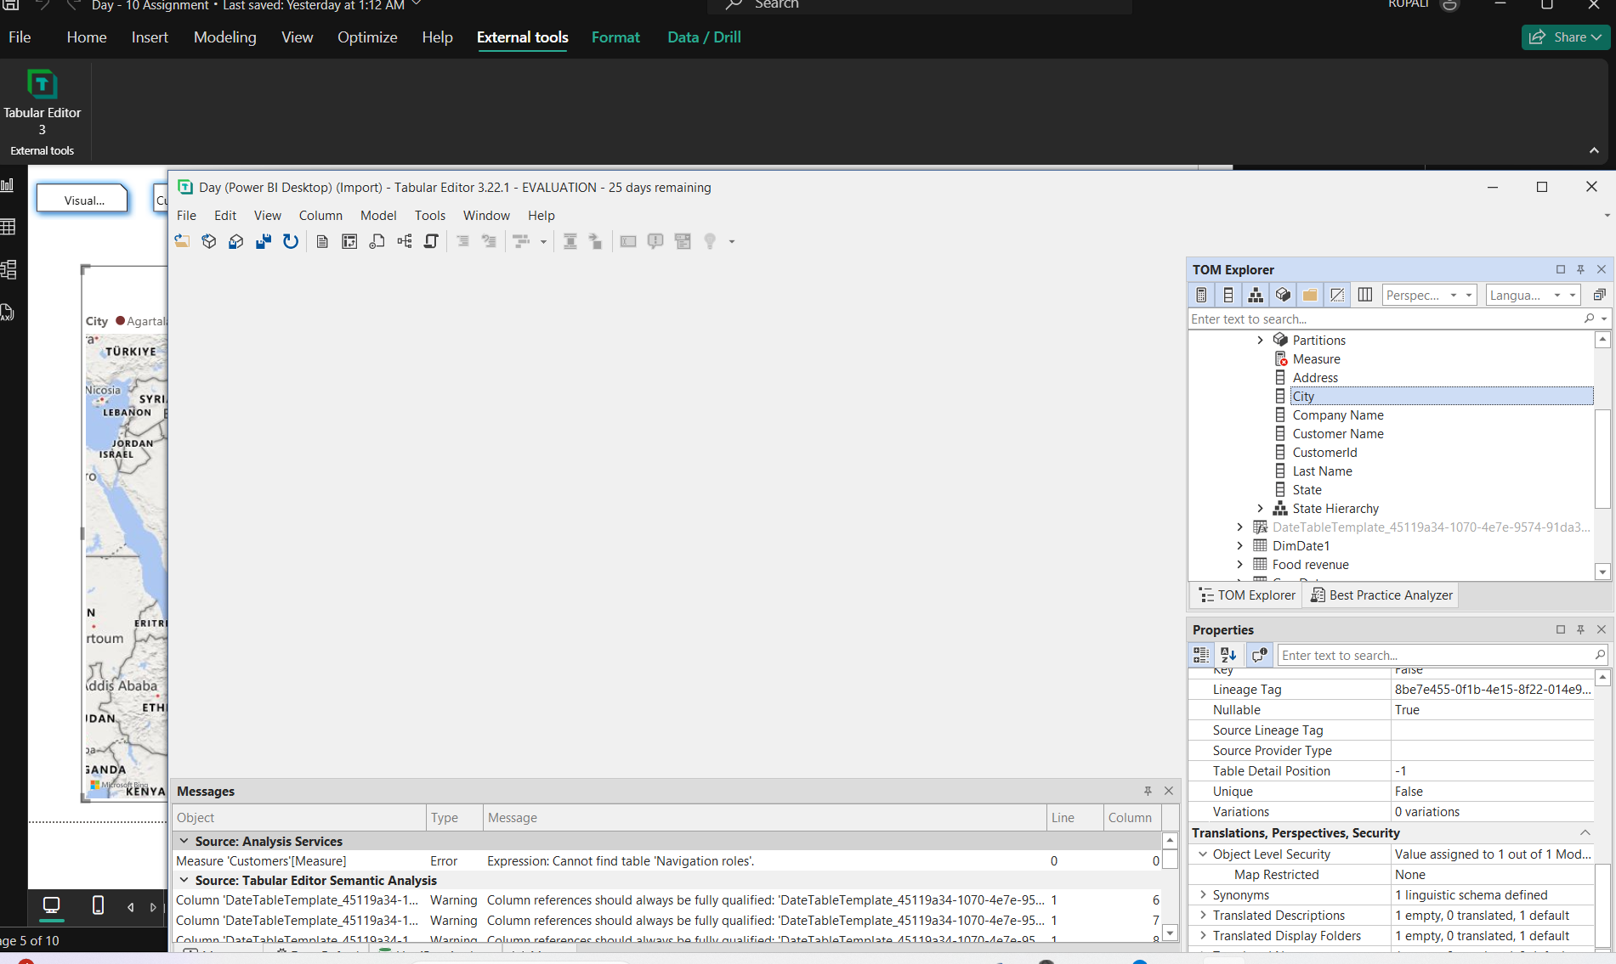

Here, the below snapshot shows the application of OLS on State. As both the city as well as the state locations were used under the filled map.

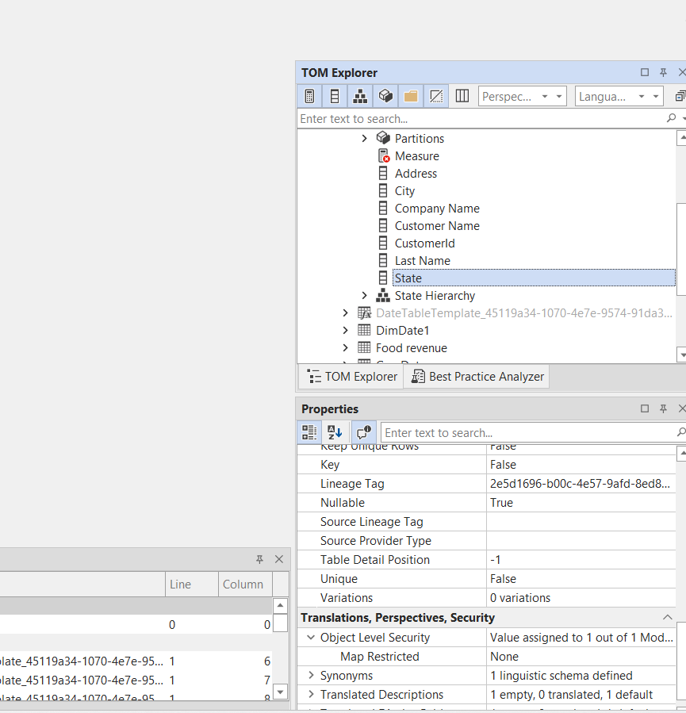

The next screenshot is of Power BI Desktop taken from the assignment 10 in order to showcase the result after applying the OLS on the filled map.

When we view the role as other user and apply the Map Restricted the Power Bi desktop shows the pop-up or error as shown in the screenshot below.

Hence, this confirms that the OLS has been successfully applied on the visual.

